Outcome (x) | P(x)
6 | .2
7 | .2
8 | .2
9 | .2
10 | .2
A B C

D
Outcome (x) | -0.3 | 0.2 | 0.15 | 0.35
Prob(x) | 0.3 | 0.2 | 0.25 | 0.25

E
F
A table has its outcomes as 1,2,3,4,5; its probabilities are .3, .3, .3, .3, .3. These are the only outcomes and probabilities in the table.

QUESTIONS 1---6 ARE TRUE FALSE T or F
1 | THERE IS ENOUGH INFORMATION IN FIGURE A TO DETERMINE THAT IT REPRESENTS A VALID DISCRETE PROBABILITY DISTRIBUTION GRAPH | F
2 | FIGURE B REPRESENTS A VALID DISCRETE PROBABILITY DISTRIBUTION TABLE | T
3 | FIGURE C REPRESENTS A VALID DISCRETE PROBABILITY DISTRIBUTION GRAPH | F
4 | FIGURE D REPRESENTS A VALID DISCRETE PROBABILITY DISTRIBUTION TABLE | T
5 | Scenario E REPRESENTS A VALID DISCRETE PROBABILITY DISTRIBUTION GRAPH | F
6 | FIGURE F REPRESENTS A VALID DISCRETE PROBABILITY DISTRIBUTION GRAPH | T

7 | After being stuffed and rolled, involtini are often tied with string. The Caruso Involtini Company purchases this string from vendors throughout the USA. Caruso’s buys 360,000 feet of string every year-----some of which is defective. It was found that 1.09 % of the string is defective, meaning some of it is either frayed or cut or otherwise unfit for its use. Find the mean length of defective string. ( also known as braciola)  Round to 2 decimal places 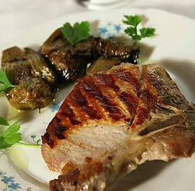  np = (360,000)(0.0109) = 3924 feet | 3924 feet
8 |   332,000 acres of onion are planted in the US every year. If 33.59% of the onions are red onions , find the standard deviation of the number OF ACRES of red onions planted.  Round to 2 decimal places  sqrt(np(1-p)) = sqrt(332,000)(0.3359)(1-0.3359) = 272.14 | 272.14
9. | Calculate the mean of this discrete probability distribution:  Use as many columns as you need.  Sum of the values in the 3rd column = 776.64  Round to 2 decimal places | 776.64
  x | P(x) | x*P(x)
  108 | 0.23 | 24.84
  120 | 0.19 | 22.80
  300 | 0.43 | 129
  4000 | 0.15 | 600
10. | Use a calculator or a table or the formula to find: binompdf(13, .6, 6)  Round to 4 decimal places  P(6) = 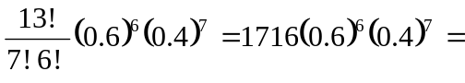0.1312 | 0.1312
11 | Kennywood Park reports that they sell 650,000 tickets in a season. The tickets are sold by agencies that represent KP-such as Giant Eagle, Eat n Park, Toys R Us, etc. KP reports that 12.08% of tickets were sold by Toys R Us; find the variance of the number of tickets sold by Toys R Us.  Round to 2 decimal places  Var(X) = np(1-p) = 650000(0.1208)(1-0.1208) = 69034.78 | 69034.78
12 | A raffle is held with the following prizes: one prize of $5,000; two prizes of $1,000 and 4 prizes of $500. The cost of a ticket is $50 and 400 tickets are sold.  FIND THE EXPECTED VALUE OF THIS RAFFLE  TICKET  Round answer to 2 decimal places.  E(X) = $5000(1/400) + $1000(2/400) + $500(4/400) - $50 = -$27.50 | -$27.50

13 |   The Walnut Grille in McCandless Township claims that the weather has an effect on its profit. Their studies have shown that, when it rains, they lose $ 1,200 that day and when it DOES NOT rain, they earn ( gross) $ 6,120 per day. It is known to rain near or at the restaurant 4 out of 17 days. Find the expected value of the Walnut Grille. State your answer in its proper format and round to two decimal places.  E(X) = $6120(13/17) + (-$1200)(4/17) = $4,397.65 | $4,397.65

14 | STUDY THE STATEMENTS  ANSWERS
  Statement 1 | 12% of people visit the doctor twice per year  - Binomial b. not binomial | b
  Statement 2 | 15% smoke tobacco; 10% chew tobacco and the rest do not use tobacco  - Binomial b. not binomial | b
  Statement 3 | Emma asked two people if they drive, walk or take the bus to campus  - Binomial b. not binomial | b
  Statement 4 | Ryan asked 1000 people if they drive to campus  - Binomial b. not binomial | a

15. A survey revealed that 40% of movie goers will eat some amount of popcorn during a movie. If the next 17 movie goers are asked if they will eat popcorn during the next movie they attend, what is the probability that at least 8 will say they will eat popcorn during the next movie?

REQUIRED TO DISPLAY YOUR ANSWER WITH 4 DECIMAL PLACES

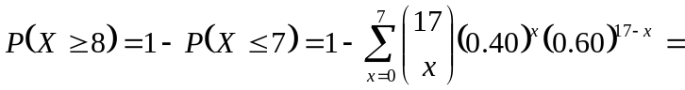1-binomcdf(17,0.4,7) = 1-0.6405 =
0.3595 (answer)

16. A game is played using three 6-sided dice. You throw these dice one time and if the dice all show the same number ( triples), you win $ 40.00 . For this game to be “fair”, how much should a person pay to play this game ?

Solution:
There are 6*6*6 = 216 possible outcomes for this game.
We win the game if the outcome is an element of the following set:
{(1,1,1), (2,2,2), (3,3,3), (4,4,4), (5,5,5), (6,6,6)}
The set above has 6 elements.
Hence, the probability of winning the game is 6/216 = 1/36

Let x be the fair price.
40(1/36) – x = 0
x = 40/36 = 10/9 = $1.11
For this game to be fair, a person should pay $1.11 per game.

